**C Programming and Data Structures**

**Computer Science and Technology-B**

**Week 11**

1. **Write a C program to swap two integers using pointers. You have to write a swap function that will accept the address of two integers and swap their values**

**Program:**

#include<stdio.h>

int swap(int m,int n);

void main()

{

int a,b,temp;

printf("Enter a value:");

scanf("%d",&a);

printf("Enter b value:");

scanf("%d",&b);

printf("Before swapping : a=%d, b=%d",a,b);

swap(&a,&b);

printf("\nAfter swapping : a=%d, b=%d",a,b);

}

int swap(int m,int n)

{

int *p,*q,temp;

p=m;

q=n;

temp=*p;

*p=*q;

*q=temp;

}

**Output:**

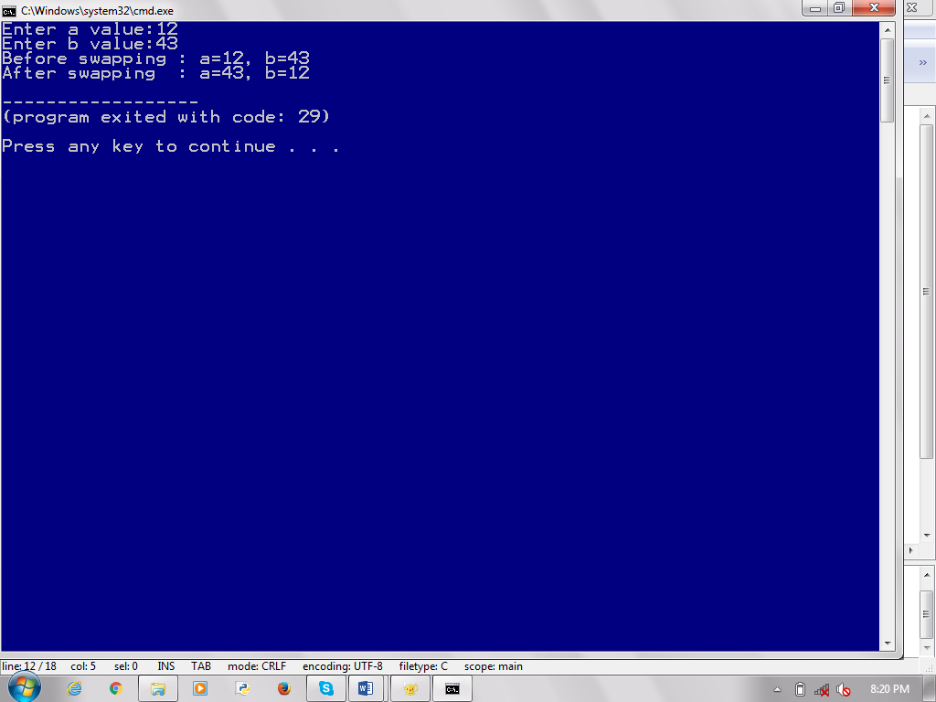

1. **Write a program in C to add two numbers using pointers. You have to write the fsum() function which accepts the address of two variables and returns the sum of their values to the main function.**

**Program:**

#include<stdio.h>

int fsum(int m,int n);

void main()

{

int a,b;

printf("Enter a value:");

scanf("%d",&a);

printf("Enter b value:");

scanf("%d",&b);

printf("Sum:%d",fsum(&a,&b));

}

int fsum(int m,int n)

{

int *p,*q;

p=m;

q=n;

return *p+*q;

}

**Output:**

